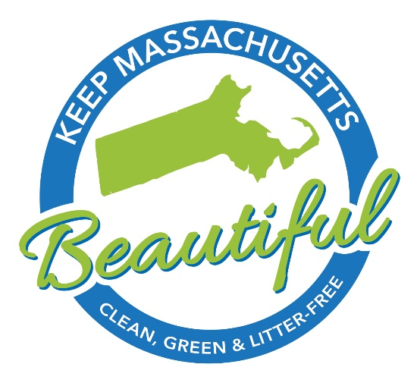

KMB Recommended Suppliers & Vendors

Below is a list of vendors that KMB and its chapters have used and recommend*. In some cases, we have negotiated favorable pricing and discounts on behalf of the KMB chapter network.
Litter Cleanup Tools:
We recommend the Garbo Grabber™. We have been using this trash cleanup tool for several years and found it to be durable and effective. The company is also based in Connecticut, which means fewer carbon emissions from shipping!
- The Reacher (34” overall): $11.00/each. Orders of 100+ qualify for free shipping (Full retail price is $16.95)
- The Collapsible Reacher at $11.00/each. Orders of 100+ qualify for free shipping
- Stickers customized with your chapter’s name and website can be added for $0.95/each.
- Note: If you don’t need 100, consider grouping your order with another chapter to qualify for free shipping.
- Individuals can order small quantities off the Garbo Grabber website at www.garbograbber.com/shop. Be sure to use the coupon code KEEPMASSBEAUTIFUL15 to save 15% off your order. Note: 5% of every sale through this link will be donated to Keep Massachusetts Beautiful.
- ArcMate (www.arcmate.com) also offers an inexpensive, light duty Qwik-Pik tool for as low as $3.20 each. We have used them and they do work, but they are not as effective or durable as the Reacher from Garbo Grabber.

The Trash Bagger and The Trash Bagger with Reusable Net Bag Combo from Garbo Grabber are designed to improve the way litter and debris are picked up by keeping the mouth of the bag open during use. To learn more about this product, visit www.garbograbber.com/shop.
- Trash bagger: $24.95
- Trash Bagger with Reusable Net Bag Combo: $31.95
  - 15% off 1-25 units + shipping
  - 20% off 26-50 units + shipping
  - 25% off 51-99 units + shipping
  - 30% off 100+ units + shipping
Trash bags: Garbo Grabber sells clear, 33 gallon, 1.1 mil-thick bags
- KMB chapter price is $59.50/box (250 per box) + shipping. Full retail price is $70/box.
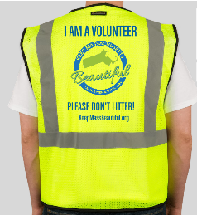
Volunteer Safety Vests:
Garbo Grabber offers customized vests at $15.95 + FREE SHIPPING for orders of 50 or more vests. These vests feature a two-color logo on the back. For quantities of 72 or more, pricing may be lower. www.garbograbber.com/shop.

Volunteer Tee Shirts:
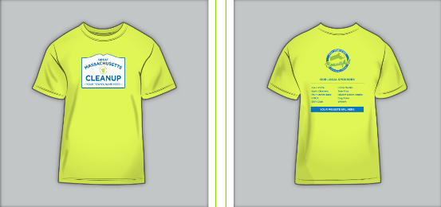
We have been partnering with Create My Tee (www.createmytee.com) for several years. They provide high quality shirts and great service.

For 2023, we have negotiated the following discounted rates.
- Orders of 100 shirts or more are $7.00 each
- Orders of < 100 shirts are $10.00 each. Note: there is a minimum order size of 25 shirts
- Free shipping!
The following stipulations apply:
- Base pricing includes: 2-color front and 2-color back
- No charge for vector format files and/or a list of sponsors on front or back of shirts
- A $150 fee will be charged if Create My Tee has to recreate sponsor logos
- Artwork on sleeves adds $1.00 per shirt
- To place an order, email steve@createmytee.com and copy neil@keepmassbeautiful.org.
Hats, Hoodies, Bumper Stickers, and Car Magnets:
Custom Ink provides high quality, customized clothing at reasonable prices. Visit www.customink.com. Use this link to save 10% off your order:
Gloves:
We recommend rubber-lined gloves for volunteers over canvas gloves. ArcMate offers good quality, washable gloves for $2.00/pair, plus shipping. These gloves are made of natural polyester/cotton.
- To order, go to https://arcmate.com/glovewithbluelatexpalm12-pairs.aspx
- Note: We recommend that you also offer non-latex gloves for people who are allergic to latex.
Anti-Litter Yard Signs:
To order eco-friendlier yard signs, we recommend Practical Image. They sell double-sided full color signs made from weatherproof coated fiberboard for approximately $3.00 each (depending on quantity ordered). Visit www.practicalimage.com for more details or to place an order.
Website Design & Support:
The KMB website was built and is hosted by Firespring. This company specializes in supporting nonprofit websites. We highly recommend them.
- Learn more at www.firespring.com/refer.
- Note: If you do decide to hire Firespring, please email neil@keepmassbeautiful.org to ensure KMB gets credit for the referral!
If you have suggestions for other products or services you’d like to see listed here, please let us know!
*Please note that in some cases, these recommended vendors donate a percentage of each referred sale back to Keep Massachusetts Beautiful. This funding is not the basis for our recommendations, which are based on quality and best pricing for KMB chapters.

